Name: Smruti Padhi

Roll No.: 21251

Sec: CSE C

1) Making a directory and creating files inside the directory

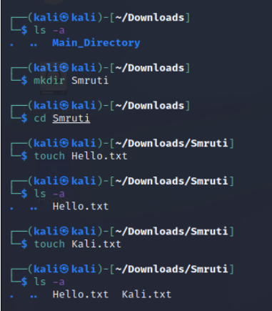

2) Inserting some text in both the files

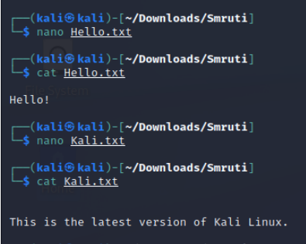

3) Copying the contents of file 1 to file 2

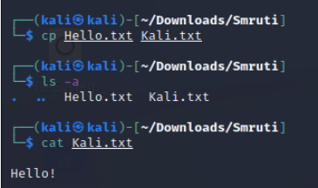

4) Moving the location of file 1 to file 2

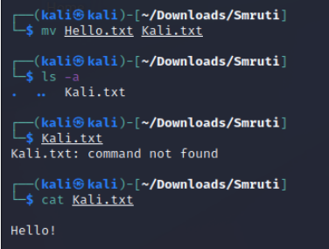

5) Deleting the files inside the directory

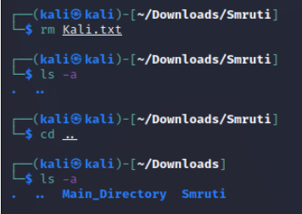

6) Removing the directory from the Downloads

